Policy for the provision of unwashed Post-operative Cell Salvage in adults

Author:

Policy ratified by:

Responsible Officer: | Signature:
Date: | Insert Date

Classification: | Clinical | Date Issued:
Area Applicable: |  | Review Date:
Ref No: |  | Version No:

Disclaimer

When using this document please ensure that the version you are using is the current, in date version by checking on your Organisations database for any new versions. If the review date has passed please contact the author.

OUT OF DATE POLICY DOCUMENTS MUST NOT BE USED

Generic policy written by the UK Cell Salvage Action Group – adapted from an original document developed in Wales by the Better Blood Transfusion Team

The UK Cell Salvage Action Group is not responsible for any changes made to this policy after its publication
Guidance

This policy has been written to support the implementation and use of unwashed, filtered, Post-operative Cell Salvage systems (Post-operative Autologous Wound Drains).

This policy does not relate to the use of Intraoperative Cell Salvage devices or devices specifically designed for Intra and Postoperative Cell Salvage i.e. systems that work by separation of the red blood cells using centrifugation.

This policy supports the use of unwashed Post-operative Cell Salvage in adult patients only. The policy does not cover the use of unwashed Post-operative Cell Salvage in paediatric patients. Unwashed Post-operative Cell Salvage in paediatric patients should be covered in a separate policy.
Contents

1 | Introduction | Page 3
2 | Policy Statement | Page 4
3 | Aims | Page 5
4 | Objectives | Page 6
5 | Responsibilities | Page 7
6 | Training | Page 9
7 | Indication and Patient Selection | Page 10
8 | Contraindication and Warnings | Page 11
9 | Patient Information | Page 12
10 | Conditions for Use | Page 13
11 | Quality Assurance | Page 18
12 | Adverse Event Reporting | Page 19
13 | Resources | Page 20
14 | Implementation and Distribution | Page 21
15 | Acknowledgements | Page 22
16 | References | Page 23
Appendix I | Autologous Transfusion Label | Page 24
Appendix II | Audit Proforma | Page 25
Appendix III | Post-operative Cell Salvage Competency Assessment Workbook | Page 26
Appendix IV | “Cell Salvage” Patient Information Leaflet | Page 27
Appendix V | Manufacturers’ Guidelines | Page 28
Appendix VI | NHS Blood and Transplant Information Leaflet “Will I need a blood transfusion?” | Page 29
 | NHS Blood and Transplant Information Leaflet “Will your child need a blood transfusion?” | Page 30

1 Introduction

Whilst allogeneic (donated) blood is an essential adjunct to health care, it is an expensive and limited resource (subject to the threat of future shortages) and can present a source of risk for patients, in particular the risk of “wrong blood” incidents as reported by the Serious Hazards of Transfusion (SHOT)¹ scheme.

The Health Service Circular (HSC), “Better Blood Transfusion: Safe and Appropriate Use of Blood” (2007) and subsequent National Blood Transfusion Committee publication, “Patient Blood Management: An evidence-based approach to patent care” (2014, England only) recommend that in order to make transfusion safer, provide better information for patients, avoid inappropriate blood transfusion and to ensure the best treatment, the patient must be at the heart of decisions made about blood transfusion²⁻³.

Both publications recommend that effective alternatives to allogeneic blood transfusion be explored, including the appropriate use of autologous blood transfusion techniques such as Post-operative Cell Salvage (PCS).

The use of PCS is routine in some areas of surgical practice. Blood lost post-operatively is collected into an autologous wound drain, then filtered and returned to the patient. This technique is an easily available, simple, safe and cost-effective alternative to allogeneic blood transfusion⁴.

2 Policy Statement

Utilising appropriate alternatives to allogeneic blood transfusion is cost-effective and complies with clinical governance requirements.

The collection and re-infusion of autologous blood provides an important contribution to reducing the demand for allogeneic blood. However, it is only one aspect of a strategic approach to safe and appropriate transfusion practice.

3 Aims

The aim of this policy document is to provide information that will allow clinicians to:-
- Utilise PCS in a safe and effective manner
- Safely identify suitable patients undergoing elective and/or emergency procedures where PCS could be used

4 Objectives

The objectives of this policy are to provide a rational and practical framework on which to maximise patient safety during PCS by:
- Promoting safer transfusion as part of clinical governance responsibilities
- Assisting clinical staff in the identification of patients and procedures considered suitable for PCS and outlining the indications and contraindications
- Assisting clinical staff to provide advice on options for treatment particularly where patients are anxious about the risks associated with donor blood
- Providing clear written information about the risks and benefits of autologous transfusions from blood salvaged post-operatively
- Assisting clinical staff to minimise avoidable/potential risks of autologous transfusions from blood salvaged post-operatively.

5 Responsibilities

The Organisation should define individual responsibilities and identify a clinical lead for the PCS programme.

Responsibilities associated with PCS include:
- Written authorisation (prescribing) responsibilities
- Labelling responsibilities
- Individual responsibilities
- Documentation responsibilities.

Responsibilities for Providing Written Authorisation
Salvaged blood reinfusion should be authorised (prescribed) by the responsible clinician on the documentation approved by the Organisation.

Labelling Responsibilities
The reinfusion bag/vessel should be labelled as soon as the system is attached to the patient or as soon as is reasonably practical (i.e. when the sterile field is cleared away, before the patient leaves theatre). The patient details should be handwritten and include the following:
- Full name.
- Date of birth.
- Unique identification number.
- Expiry date and time of the salvaged blood.
- The statement “Untested Blood –“For Autologous Use Only”⁵.

Addressograph labels should not be used because of the known associated risks⁶.

The use of a generic autologous transfusion label (Appendix I) is recommended. This should be used alongside any device specific documentation supplied by the manufacturer.

Individual Responsibilities
Individual staff should ensure that they are adequately trained and competent in the use of the PCS system and their individual responsibilities according to their area of work e.g. theatre, recovery and ward. This includes the completion of the autologous blood collection phase at the appropriate time and the connection (if applicable) of the manufacturer specified waste drainage bag/vessel to the system, at the end of blood collection, to minimise the risk of re-infusing blood, that is shed post-operatively, beyond the specified time and volume limits. Staff should not use equipment for which they have not been trained and competency assessed.

Documentation Responsibilities
Staff should ensure that documentation (including all appropriate labelling) accurately reflects the PCS process, (including the drainage and re-infusion episode.) The documentation record should include:

- The PCS audit form (Appendix II)

- The autologous transfusion label (Appendix I) should be completed and attached to the reinfusion bag/vessel

- At the time of reinfusion of the salvaged blood, the peel out section on the autologous transfusion label (Appendix I) should be completed and attached in the appropriate place in the patient’s clinical record or equivalent as specified in the Organisation’s Transfusion Policy (Policy Document Ref No. for the Organisation’s Transfusion Policy should be entered here)

- Bedside pre-transfusion checks and patient observations, prior to, during and after PCS blood reinfusion, should be performed and recorded in the same way as for the transfusion of allogeneic blood (Policy Document Ref No. for the Organisation’s Transfusion Policy should be entered here). Additional observations are at the discretion of the clinical staff based on an individual patient assessment

- Adverse incidents should be documented in the patient’s clinical records (or other as identified by the organisation) and reported as in section 12.

6 Training

- Key personnel should be identified in each clinical area as a contact for communication and training. This person will maintain training records of staff who have received training in the use of the PCS system (a copy of this record may be sent to the Transfusion Practitioner or other designated person (specify) for central collation).

- Theoretical and practical training should be undertaken and staff should be competency assessed before they set up or operate the PCS equipment without supervision.

- Training and competency assessment in the administration of the PCS blood should be carried out to the same standard as for the administration of allogeneic blood.

- Individual staff should receive training in the indications, contraindications and technical differences specific to their area of practice. While PCS is usually restricted to use in orthopaedic procedures, if it is used outside of this speciality, staff should receive training specific to the speciality it is to be used in.

- Staff carrying out PCS for Jehovah’s Witness patients should have received training and have been competency assessed in preparing the equipment and blood for reinfusion in accordance with the patient’s religious beliefs prior to carrying out the procedure.

- A PCS Competency Assessment Workbook is available via the Transfusion Practice section of the JPAC website, at: www.transfusionguidelines.org.uk (see also Appendix III). It is strongly recommended that once assessed as competent, individuals keep an ongoing log (similar to that in the PCS Competency Assessment Workbook) of all PCS procedures they carry out.

- Staff have a professional responsibility / accountability to ensure they are up to date and competent in relation to their practice.

- Update training is recommended under the following circumstances:
- Any reasonable length of time without practical use of the PCS system
- A learning need is identified by an individual member of staff or supervisor
- Changes in the product from the manufacturer or a change in the product due to the Organisation trialling/purchasing new products
- Changes to national and/or local guidelines relating to any aspect of autologous transfusion (including changes to the Organisation’s Blood Transfusion Policy)
- Following an incident or error.

Individual Responsibilities
Individual staff should ensure that they are adequately trained and competent in the use of the PCS system used and their individual responsibilities according to their role and area of work e.g. theatre, recovery and ward. This should be monitored through the annual appraisal process with the line manager.
7 Indications and Patient Selection

PCS systems may be used in elective and/or emergency orthopaedic procedures where the wound is not contaminated with substances not intended for intravenous use (including infective matter) and where no other contraindications exist (see section 8). This will include:(Individual Organisations should enter the procedures in which PCS may be used here)

Procedure related factors:
- Where the anticipated post-operative blood loss warrants PCS (check manufacturer’s guidelines for recommended minimum reinfusion volumes).

Patient related factors:
- Refusal of allogeneic blood
- Difficulty in obtaining compatible allogeneic blood
- Patients with a low haemoglobin
- Increased risk of bleeding.

- Patient selection for PCS is at the discretion of the surgeon and anaesthetist caring for the patient.

- The process should be discussed with the patient pre-operatively at the earliest opportunity and documented accordingly. If it is not possible to discuss the process with the patient pre-operatively (e.g. in an emergency procedure), it is good practice to inform the patient retrospectively.
- Autologous transfusion may be acceptable to Jehovah’s Witness patients, but must be discussed pre-operatively with the individual and their decision documented accordingly.
- If the surgical procedure to be carried out is associated with any of the contraindications as listed in section 8, the potential risks and hazards should be discussed with the patient and their agreement to undergo PCS documented in the patient’s clinical records.
8 Contraindications and Warnings

The risk benefit ratio of PCS should be assessed for each individual patient by the surgeon and anaesthetist responsible for the patient’s care.

Contraindications
- PCS should not be used in the following situations:

- Where there is localized infection in the surgical site
- In patients with clotting disorders or red cell disorders e.g. sickle cell disease
- Where non-IV substances have been introduced into the wound e.g infiltration of wound edges with local anaesthetic
- If the patient declines the use of PCS
- If any of the clinical team are unfamiliar with use of the PCS device.

  - PCS may not be appropriate for:
- Patients with malignancy.

Warnings
- If the system leaks blood or lets in air at the wound site from perforated holes in the wound drain being above the skin surface or at the connection junction, the sterility of the collection has been compromised. In this case discard the collection device and replace with a standard vacuum wound drain.

- In cases where the patient may have an infectious disease, the organisation’s Infection Control Policy (Policy Document Ref No. for the Organisation’s Infection Control Policy should be entered here) should be followed for dealing with and disposing of equipment contaminated with infected material.

Cautions

Risks of PCS
The risks of PCS are minimal provided that a standard 40 micron filter is used for re-infusion and that the device manufacturer’s standard operating procedure is followed.
The following may contribute to theoretical risks:

- Clerical error (if device leaves patient’s side)
- Air embolus (if non-adherence to manufacturer’s instructions)
- Free Haemoglobin
- Tissue debris/clot
- Red cell debris
- Bone marrow fat embolus (PCS device should remove fat)
- Fibrin degradation products and/or activated coagulation factors (risk of developing coagulopathy)
- Toxic irrigants (not a risk if wound thoroughly washed out with iv grade saline prior to closure/drain insertion)
- Methacrylate (‘cement’) debris.
9 Patient Information

- Patients considered likely to have PCS following planned surgery should receive information about PCS before their operation. The process should be discussed with the patient pre-operatively at the earliest opportunity and supported by provision of written information – for example patient information leaflet “Cell Salvage” (Appendix IV).

- For patients undergoing emergency surgery, when PCS cannot be discussed beforehand, the use of PCS is at the discretion of the surgeon and anaesthetist responsible for the patient’s care.
10 Conditions for Using PCS

Use of PCS Equipment

- The PCS equipment should be used in accordance with the Manufacturer’s guidelines (Appendix V).

- All procedures should be carried out in accordance with the Organisation’s PCS policy and procedural documents.

- Contraindications should be considered as identified in section 8.

- All staff who set up, operate or are responsible for the PCS system should receive theoretical and practical training (see section 6) and should have completed the PCS Competency Assessment Workbook (Appendix III).

- Staff should comply with hospital policies for infection control, management of sharps and blood transfusion.

- Clean/non-touch/aseptic technique should be used as appropriate, to reduce the risk of infection.

Labelling

- All salvaged blood should be labelled – the use of a generic autologous transfusion label (Appendix I) is recommended.

- Labels should be handwritten. Pre-printed “addressograph” labels should not be used.

- Labelling information should include as a minimum:
  - last name
  - first name
  - date of birth
  - unique patient ID number
  - expiry date and time
  - The statement “untested Blood – For Autologous Use Only” ⁵.

- To avoid errors in patient identification, an autologous transfusion label (Appendix I) should be completed at the patient’s side once the PCS system has been connected to the patient and before the patient leaves theatre i.e. the PCS system should not be pre-labelled prior to connection to the patient.

- The patient details must be taken from the identification band attached to the patient and not from any clinical records or charts that may be present in the operating theatre. All fields on the label should be completed in full.

- The completed label should be attached immediately to the PCS system reinfusion bag/vessel, before the patient leaves theatre.

Recommendations for labelling:
- Label all autologous blood with the patient’s details
- Label the autologous blood using the information on the patient’s ID band. Do not use addressograph labels
- Ensure the autologous blood is labelled with the patient’s details before the patient leaves theatres.

Reinfusion

- The decision to reinfuse the salvaged blood should be made on an individual patient basis taking into account the patient’s clinical need and the benefits of reinfusing the blood versus the potential risks. Reinfusion of the salvaged blood should follow standard blood transfusion practice (Policy Document Ref No. for the Organisation’s Transfusion Policy should be entered here). The responsible clinician should authorise salvaged blood for reinfusion in the same manner as for allogeneic blood.

- The reinfusion bag/vessel, should be kept beside the patient at all times.

- PCS blood must never be placed in a refrigerator/Blood Bank fridge.

  - Positive Patient Identification must be confirmed prior to reinfusion commencing.The patient details on the reinfusion bag must be carefully checked against the details on the identification band attached to the patient before connecting the reinfusion bag to the patient.

- Salvaged blood from the PCS system reinfusion bag/vessel is reinfused to the patient via an intravenous cannula and using an appropriate filter (see below). The person administering the reinfusion adjusts the rate at which the salvaged blood is reinfused (see below) using a roller clamp on the administration set and by adjusting the height of the reinfusion bag. Do not apply a pressure cuff to increase the flow rate because of the risk of air embolism.

- Providing the time limits and maximum reinfusion volumes have been exceeded, it may be possible to continue to salvage postoperative blood loss (for later reinfusion) once reinfusion of the salvaged blood has begun. (Enter manufacturer’s specific guidance for this process here if applicable to the system used in the Organisation). If the time and volume limits have been exceed, the manufacturer’s guidance for completing the PCS procedure and attaching the recommended waste drainage bag/vessel should be followed.

- Patient observations pre, during and post transfusion should be performed and recorded during autologous blood reinfusion in the same way as for the transfusion of allogeneic blood (Policy Document Ref No. for the Organisation’s Transfusion Policy should be entered here). Additional observations are at the discretion of the clinical staff based on an individual patient assessment.

- A filter, as recommended by the PCS system manufacturer, should be used for reinfusion.

- The recommended reinfusion rate for PCS blood using the (insert system name here) system is (insert manufacturer’s recommended reinfusion rate here)ml/hour. A clinical decision to reinfuse the salvaged blood at an increased rate may be made if a clinical need is identified.

- All salvaged blood must be reinfused before the expiry time identified on the autologous transfusion label; the expiry time for unwashed PCS blood is 6 hours after the collection start time according to the American Association of Blood Banks⁵ (AABB). Therefore, the blood collection period may vary in length depending on the volume of blood collected and the rate at which it is to be reinfused e.g.

  - 600ml collected over 3 hours
  - To complete the reinfusion within the expiry time
  - Reinfusion begins at 3 hours
  - Reinfusion rate is 200ml/hour over 3 hours.

- The maximum recommended reinfusion volume for PCS blood using the (insert system name here) system is (insert manufacturer’s recommended maximum reinfusion volume here)ml.

Under no circumstances should the volume of blood reinfused exceed this amount.

N.B. If blood loss is rapid and/or sustained, the clinician in charge of the patient’s care must be contacted to urgently review the patient.
- Reinfusion of salvaged blood should be documented in the appropriate section of the patient’s clinical record or equivalent as specified in the Organisation’s Transfusion Policy (Policy Document Ref No. for the Organisation’s Transfusion Policy should be entered here).The autologous transfusion label (Appendix I), contains a peel out section which should be completed at the time of reinfusion and can be used for this purpose.

- If a transfusion reaction is suspected, the re-infusion should be stopped immediately and a clinical decision made with regard to the patient’s care. All incidents should be reported according to local policy (Policy Document Ref No. should be entered here). Depending on the severity and nature of the incident, reporting to the Serious Hazards of Transfusion (SHOT) scheme and the Medicine and Healthcare products Regulatory Agency (MHRA) may also be appropriate (See Section 12).

Recommendations for reinfusion:
- Autologous blood should be kept with the patient at all times and never refrigerated
- The responsible clinician should provide written authorisation (prescription) to reinfuse the autologous blood before the process begins
- Positive patient identification must be confirmed using the information on the autologous blood label and the patient’s ID band before beginning reinfusion to the patient
- Pre-transfusion checks and pre/during/post-transfusion patient observations should be carried out as for allogeneic blood transfusions
- An appropriate filter should be used for reinfusion
- The reinfusion rate for PCS blood should be in accordance with manufacturers’ guidelines. A clinical decision to increase this rate can be made based on clinical need
- The reinfusion should be completed before the expiry time identified on the autologous transfusion label
- The maximum volume for reinfusion should be identified and documented for each patient
- The reinfusion should be clearly documented in the patient’s clinical records.

Expiry

- The total time for collection and reinfusion of salvaged blood should be completed within the timeframes as recommended by the AABB⁵ . The AABB Standards⁵ state the expiry times for PCS blood as: 6 hours from the start of collection. Therefore collection and reinfusion should be completed within 6 hours. (If the Organisation’s Transfusion Policy or procedural documents for PCS specify a shorter collection and reinfusion time, this should be considered to be the maximum timeframe (expiry time) and should be entered into this section of the policy).

- Any blood that has not been reinfused within the timeframes specified should be disposed of in accordance with local policy for dealing with liquid biohazardous waste (Policy Document Ref No. should be entered here).

Recommendations for expiry:
- Reinfusion of PCS blood should be completed within 6 hours from the start of collection
- Any expired blood that has not been reinfused should be disposed of in accordance with local policy.

Documentation

- The collection and reinfusion of salvaged blood should be accurately documented on an appropriate form such as that in Appendix II.

- The use of a generic autologous transfusion label (Appendix I) is recommended – the peel out section of the label is completed and attached to the patient’s clinical record upon reinfusion of the salvaged blood.

- Adverse incidents and serious adverse events should be documented/reported (see Section 12).

- Bedside pre-transfusion checks and associated patient observations should be performed and recorded during autolgous blood reinfusion in the same way as transfusion of allogeneic blood and in accordance with the Organisation’s Blood Transfusion Policy (Policy Document Ref No. for the Organisation’s Transfusion Policy should be entered here). Additional observations are at the discretion of the clinical staff based on an individual patient assessment.

- The Organisation should ensure that adequate records are retained in all cases where PCS is used.

Disposal of Used PCS Equipment

- Following use, all PCS disposable equipment should be disposed of in accordance with the Organisation’s Health and Safety Policy for disposal of equipment contaminated with blood (Policy Document Ref No. should be entered here).

11 Quality Assurance

The Organisation should maintain comprehensive quality assurance systems to ensure the provision of a safe, high quality PCS service.

Personnel
The Organisation should identify a single individual responsible for ensuring that a safe and effective PCS service is provided. This individual should be responsible for ensuring that quality assurance systems are fully implemented.

The Organisation should ensure that competent personnel in sufficient numbers are available to provide the PCS service, including for out of hours cases if applicable. Personnel involved in PCS should have undergone appropriate training (see section 6) and competency assessment (Appendix III). Organisations should maintain training records for all staff involved in the PCS process and it is highly recommended that individuals maintain a case log of all procedures in their own portfolios.

Equipment
All PCS equipment should be appropriately stored according to the manufacturer’s guidance.

Product Quality

Where local policy/procedural documents exist within an Organisation, they should be included/referred to in this section.

12 Adverse Event Reporting

- Technical problems with the PCS system should be reported to the manufacturer.

- Serious Adverse Events must be reported to the clinical lead for PCS and the Organisation’s Transfusion Practitioner. Any adverse events relating to the PCS system must be reported in accordance with the Organisation’s Incident Reporting Policy (Policy Document Ref No. should be entered here). Additionally, where appropriate, reporting to the relevant external bodies should be undertaken e.g. SHOT¹ and the Medicines and Healthcare Products Regulatory Agency (MHRA)⁷, especially if the incident has led to or, were it to occur again, could lead to death, life-threatening illness or injury. Other minor safety or quality incidents should also be reported as these can help demonstrate trends highlighting inadequate manufacturing, supply systems or instructions and/or training.

- Adverse events should be documented in the patient’s clinical records.

- Examples of adverse events include:
- Severe reaction on reinfusion of salvaged blood
- Non-labelling / incorrect labelling of salvaged blood
- Equipment malfunction
- Communication failure leading to inappropriate reinfusion of the salvaged blood.

13 Resources

The provision of safe PCS requires adequate resources for the formal, documented training of all staff who set up or operate the equipment.

14 Implementation and Distribution of the Policy

- This policy document should be circulated to all relevant personnel and implemented in all areas which may be involved in PCS e.g.
  - Medical Director
  - Nursing Director
  - Clinical Director, Trauma and Orthopaedics
  - Clinical Director, Anaesthetics
  - Theatre Manager
  - Chair of Hospital Transfusion Committee
  - Consultant Haematologist (Lead for Blood Transfusion)
  - Transfusion Practitioner.

- The procedure document will be reviewed at timely intervals and when new information becomes available.

- Guidance on and queries relating to the document should be addressed to the Organisation’s clinical lead for PCS (Organisations should insert the name of the clinician responsible for PCS here).

15 Acknowledgements

- Maria Roberts, Transfusion Practitioner, Welsh Blood Service/Cardiff and Vale NHS Trust for her original Postoperative Cell Salvage procedure document on which the All Wales Policy for Post-Operative Autologous Blood Transfusion Drainage Systems was based⁸

- The Welsh Blood Service Better Blood Transfusion Team⁹

- The members of the UK Cell Salvage Action Group
(www.transfusionguidelines.org.uk)

16 References

- Serious Hazards of Transfusion (SHOT) Report 2009 – current year http://www.shotuk.org/shot-reports/ (accessed 26.03.2015).

- Better Blood Transfusion: The Safe and Appropriate Use of Blood (2007) HSC 2007/001.

- National Blood transfusion Committee (2014) Patient Blood Management: An evidence-based approach to patient care. http://www.transfusionguidelines.org/uk-transfusion-committees/national-blood-transfusion-committee/patient-blood-management (accessed 26.03.2015).

- Thomas, D., Thompson, J. and Ridler, B. eds., (2005) A Manual For Blood Conservation. Shrewsbury: tfm Publishing Ltd. p123

- American Association of Blood Banks (AABB) (2013) Standards for Perioperative Autologous Blood Collection and Administration (5th Edition).

- British Committee for Standards in Haematology (2009) Guideline on the Administration of Blood Components. http://www.bcshguidelines.com/documents/Admin_blood_components_bcsh_05012010.pdf (accessed 26.03.2015).

- Medicines and Healthcare Products Regulatory Agency (MHRA).
https://www.gov.uk/government/organisations/medicines-and-healthcare-products-regulatory-agency (accessed 26.03.2015).

- Roberts, M.M. (2006) Procedure for Post-operative Autologous Blood Transfusion Drainage Systems in Adult and Paediatric Patients (Draft). Cardiff and Vale NHS Trust.

- Welsh Blood Service Better Blood Transfusion Team (2008) All Wales Policy for Post-Operative Autologous Blood Transfusion Drainage Systems.

Appendix I

Autologous Transfusion Label

The following autologous transfusion label is available from your device manufacturer. N.B. cable ties or equivalents are not provided.

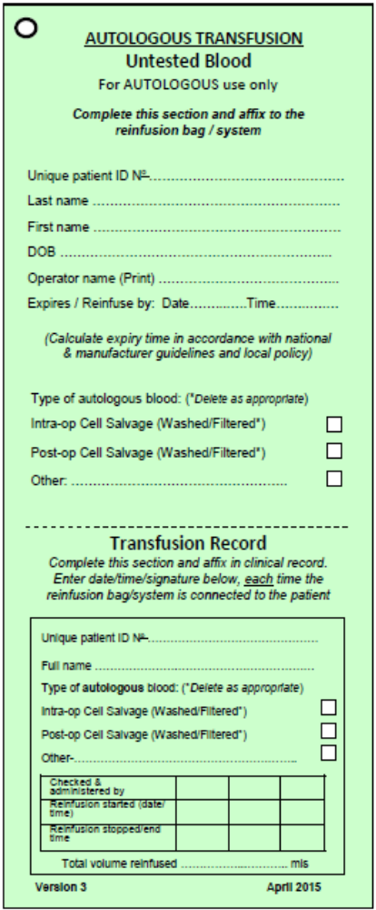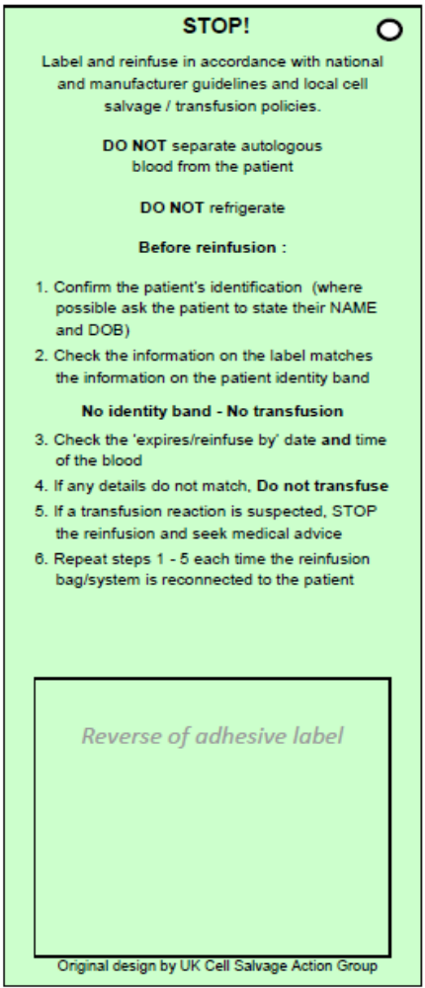

Appendix II

Audit Proforma

The organisation should attach a copy of their approved audit proforma to this section
Appendix III

Post-operative Cell Salvage Competency Assessment Workbook

The Post-operative Cell Salvage Competency Assessment Workbook is available via the Transfusion Practice section of the JPAC website, at: www.transfusionguidelines.org.uk

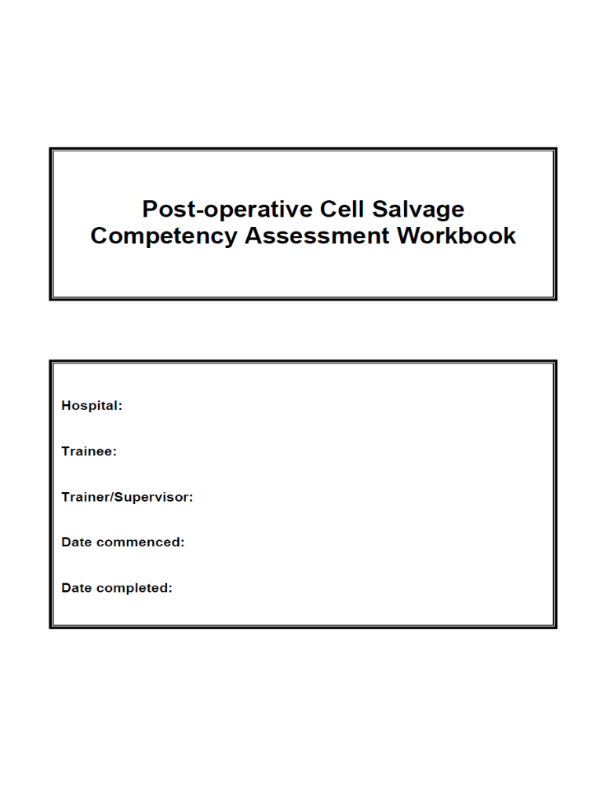
Appendix IV

“Cell Salvage” Patient Information Leaflet

The following patient information leaflet can be downloaded at:
http://www.transfusionguidelines.org.uk/transfusion-practice/uk-cell-salvage-action-group/patient-factsheet

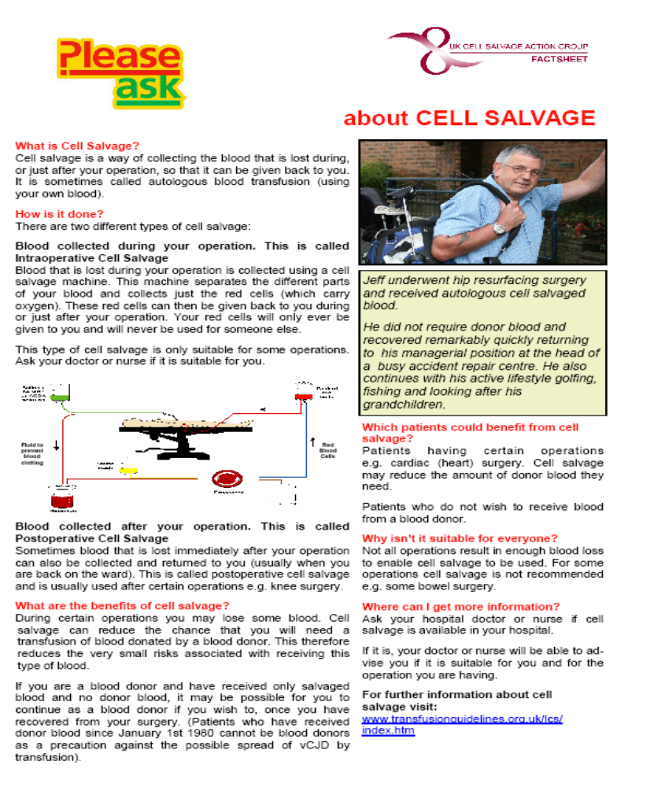
Appendix V

Manufacturer’s Guidelines

The organisation should attach a copy of the Manufacturer’s guidelines to this section
Appendix VI

NHS Blood and Transplant information leaflets

“Will I need a blood transfusion?”

These information leaflets can be ordered from: https://hospital.nhsbtleaflets.co.uk/
Alternatively the leaflets can be downloaded at:
http://hospital.blood.co.uk/patient-services/patient-blood-management/patient-information-leaflets/

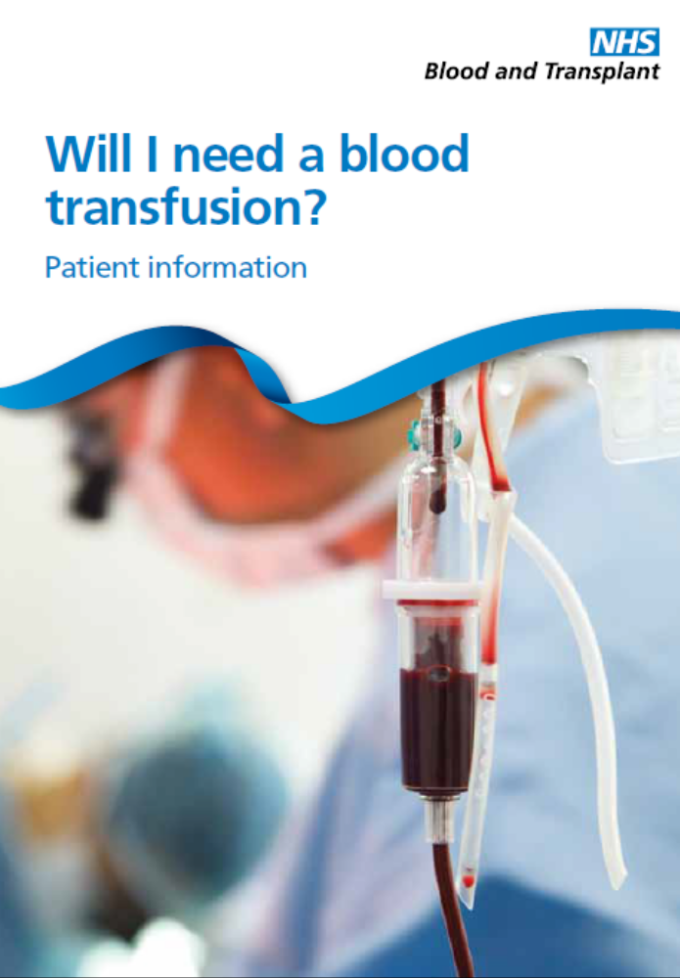

“Will your child need a blood transfusion?”



NB. These leaflets are for hospitals supplied by NHS blood and Transplant, hospitals in Wales, Scotland and Northern Ireland should contact their local blood service for the equivalent leaflet.

